ELEVATOR TRAINING SET FM-AP34 (Advanced Model)

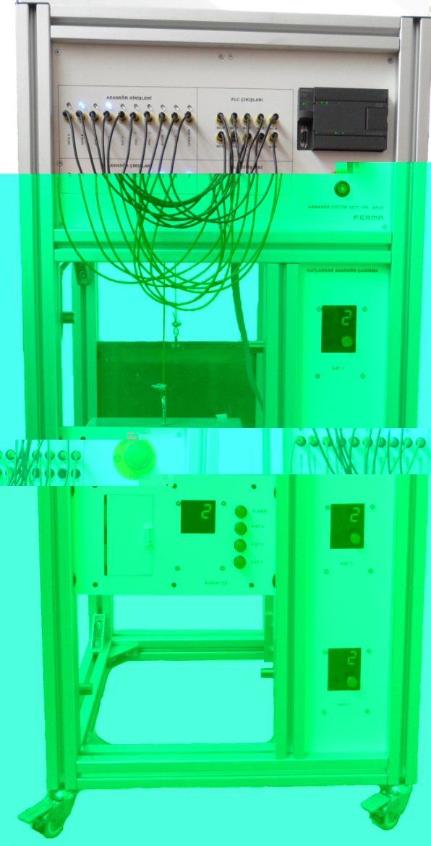
3-floor elevator traing set is designed as a sample for electromechanical control and PLC applicaitons. Its transparent structure is preferred to examine the electrical connections and mechanical parts. 45x45 anodized aluminum sigma profile is used in the construction of the set.

Siemens S7-224 model PLC is used in the control panel of the set. All inputs and outputs necessary to run the elevator and all inputs and outputs of PLC are taken out of the surface of the panel via 4 mm banana sockets. Also the states of the process can be easily followed by the LEDs which are connected to inputs and outputs of the elevator.

There are sliding door, cabin light which is activated by the electro-magnetic door lock, call and emergency stop buttons and 7-segment floor display in the elevator cabin.

Floor level and limit sensors, cabin balance weight mechanism, call buttons in the floors, 7-segment floor display, LEDs showing up/down movement and DC motor form the rest of the set.

- Supply voltage 220 VAC/ 50 Hz
- Short-circuit protected, Switch Mode 24 VDC/4.5 A Power Supply
- 4mm sockets for elevator and PLC input/outputs
- Integrated 14 digital inputs, 10 digital outputs and 10 internal relays for digital outputs
- Elevator inputs and outputs with LEDs
- Emergency stop and start up buttons
- 3 floor level sensors ( inductive sensor)
- 2 limit sensors ( inductive sensör)
- 7 segment floor display
- Arrow shaped LED group showing up/down movement
- Sliding cabin door
Accessories supplied with set
- IEC power cable
- 20 pcs 4 mm experiment cables
- Sample program software

- Electromagnetic door lock
- Cabin light
- DC motor
- Dimension: 555mm x 1.180mm x 445 mm

