2 AXES CONVEYOR BANT TRAINING SET FM-YB25

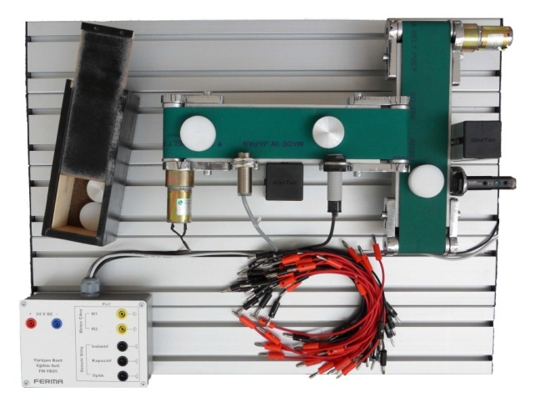
The 2 axes conveyor bant training set designed as a sample for the conveyors used in industrial systems and product classification lies on the aluminium sigma profile platform.

The control panel contains the motor’s inputs and outputs provides the communication of the training set with the control systems such as PLCs. The inputs/outputs of motor, sensors and the 24 VDC supply needed to run the system are taken out of the surface of the panel via 4mm banana sockets.

- Bant movement in x and y axes
- Inductive sensor
- Capacitive sensor
- Optical sensor
- 2 DC motor
- Control panel usable with PLC
- 4 mm banana sockets for the inputs and outputs of sensors and motors
- 24 VDC supply
- Axes lengths: 320mm
- Dimensions: 500mm x 600mm

Accessories supplied with set
- 7 pcs 4 mm experiment cables
- Product box
- White polyamid product
- Black polyamid product
- Aluminium product
- Valves and cylinders for product classification (optional)

