5+1 AXIS ROBOT ARM
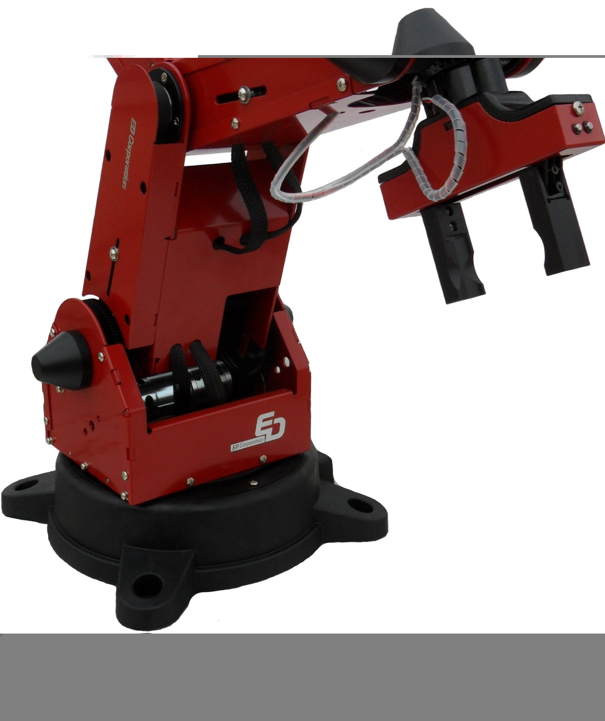

Technical Specifications

- Number of Joint: 5 joints + 1 Gripper
- Construction: Vertical Articulated Arm
- Precision: ±0,5 mm
- Movement Speed: max. 750 mm/s
- Load Capacity: 1 kg
- Actuator: DC Motor (encoder feedback)
- Body Joint Motion Range: 350º
- Gripper opening: 80 mm
- Range of Motion: max. 680 mm
- Physical Size: 280 x 280 x 786 (mm)
- Arm Length: 599 mm
- Teaching Pendant (Positions can be taught by the teaching pendant.)
- RS232 and ethernet communication
- 220V AC supply
- Inputs and outputs of the robot are isolated from the process I/Os.
- The software includes simulator.

