CONVEYOR BANT TRAINING SET FM-YB47

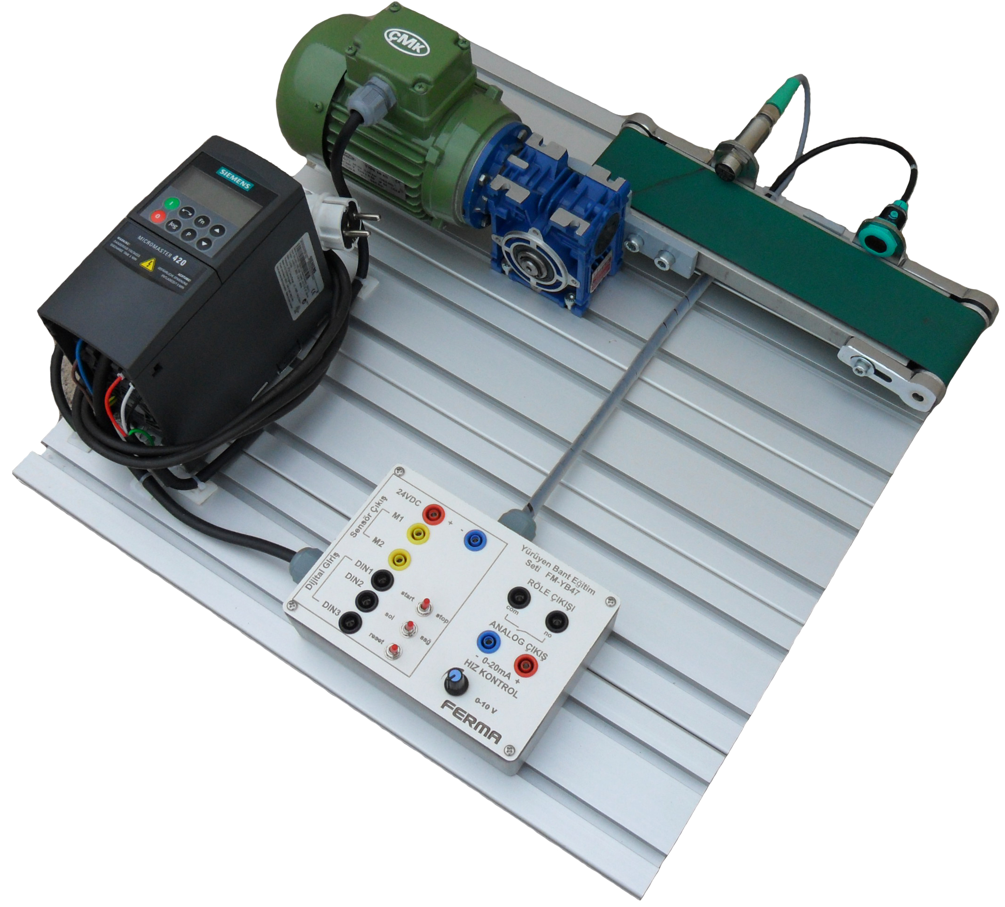
The set designed to be able to investigate the speed control device, AC motor and sensor applications all in one also contains a control panel which provides the communication of the training set with the control systems such as PLCs.

The I/Os of the speed control device and sensor outputs are taken out of the surface of the panel via 4 mm banana sockets.

- Micromaster 420 Speed Control Device
- AC motor
- Inductive sensor
- Optical sensor
- Control panel usable with PLC
- Axis bant movement
- 4 mm banana sockets for the inputs and outputs of sensors and motors
- 220 V AC power supply
- Axis length: 320mm
- Aluminium sigma profile platform dimension: 500 x 600
Accessories supplied with set
- 9 pcs 4 mm experiment cables
- Product box
- White polyamid product
- Black polyamid product
- Aluminium product
- Valves and cylinders for product classification (optional)

