PLC TRAINING SET (FP-3C)
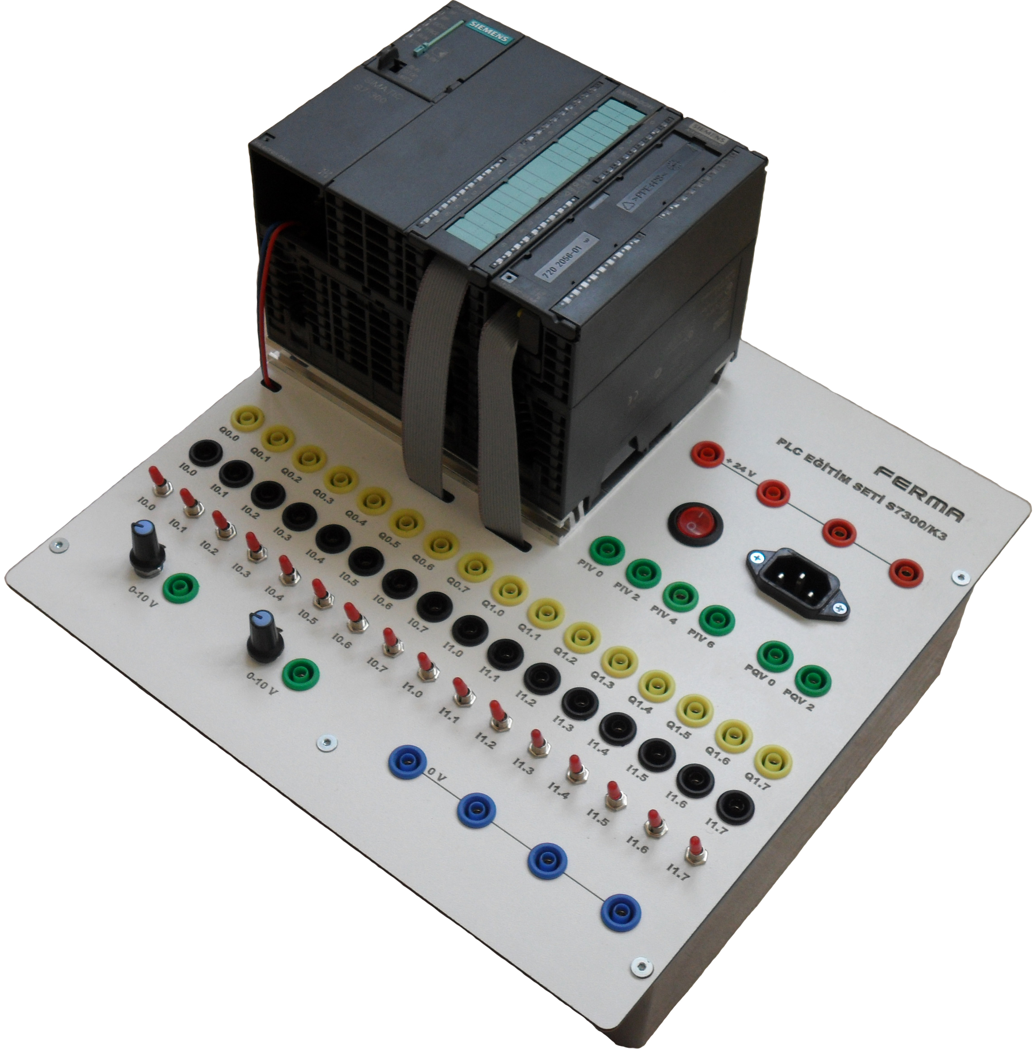
There exists Siemens S7-313C-2DP model PLC, which has 16 digital inputs and 16 digital outputs, the analog module SM-334 which consists of 4 analog inputs and 2 analog outputs and for the analog applications a 0-10 V DC potantiometer in the training set.

All digital outputs of the PLC are connected to relays and 1/0 toggle switches of the digital inputs provide easiness to the user.

All input/outputs of the PLC, connection ports of the 0-10 V DC potantiometer and internal 24 V DC power supply are taken out of the surface of the panel via 4mm banana sockets. All connections are made by 4mm infitine joggle plug-in cables.

- Supply voltage 220 VAC/ 50 Hz
- Short-circuit protected, Switch Mode 24 VDC/4.5 A Power Supply
- Integrated 16 digital inputs, 16 digital outputs, 4 analog inputs, 2 analog outputs
- 16 internal relays for digital outputs
- 16 1/0 toggle switches for digital inputs
- 2 pcs 0-10 VDC potantiometer (optional)
- Dimensions : 297mm x 300mm x 60mm
Accessories supplied with set
- USB/MPI programming cable
- IEC power cable
- 10 pcs 4 mm experiment cables
- Carriage case ( optional )

