RENEWABLE ENERGY SYSTEMS TRAINING SET (Basic Level) FR-HS

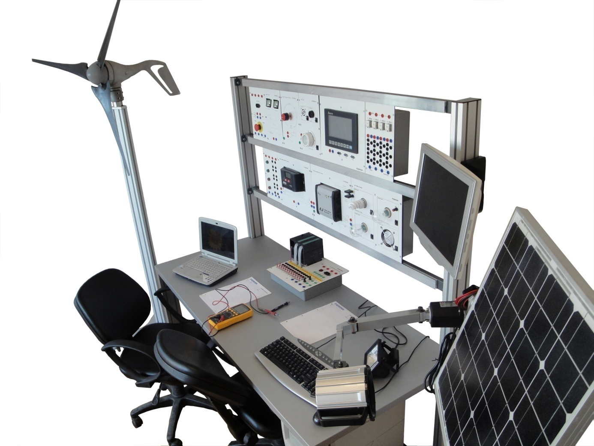

Renewable energy systems training set is designed to investigate the electricity generation with small wind turbines and solar panels. The set is a hybrid module available indoor use.

In order to familiarize the industrial devices to the students, the identical ones are used in the training set. Thanks to modular structure of the components an alternative usage by placing the modules to the “H” rails of Ferma table exists beside the usage on table top.

The renewable energy systems training set consist of;

- Small wind turbine
- Photovoltaic panel
- FY-SR10 Solar Charge Controller
- FY-IN10 DC-AC inverter
- FY-AK07 Accumulator
- FY-DR40 Variable resistor
- FY-DY03 DC load
- FY-AY04 AC load

Small wind turbine
- Power: 400 W at 28mph (12.5 m/s)
- Voltage: 12 VDC
- Rotor diameter: 46 inches (1.15m)
- Start-up wind speed: 8 mph (3.58 m/s)
- Survival wind speed: 110mph (49.2 m/s)
- Kilowatt hours per month: 38 kWh/mo @12 mph (5.4 m/s)
- Body: Cast aluminum (coated for corrosion protection)
- Blades: Carbon fiber composite (3)
- Mount: 1.9” OD, 48mm
- Turbine controller: Microprocessor-based smart internal regulator)
- Over-speed protection: Electronic torque control

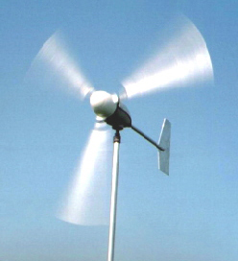

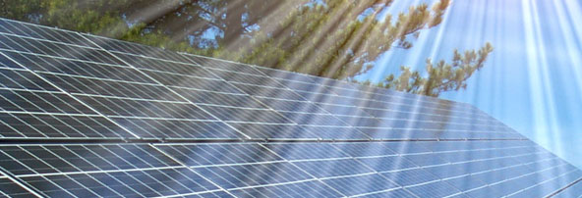

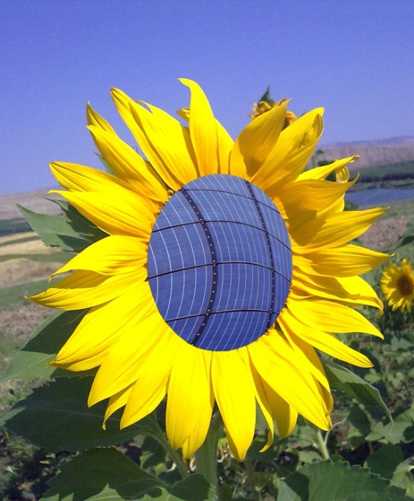
Photovoltaic panel
- Monocyrstal structure
- Max. Power: 40W
- With 32 cells
- Short circuit current: 2,75A
- Open circuit voltage: 19,48VDC
- Max. Power current: 2,53A
- Max. Power voltage: 15,84VDC
- Dimensions: 570mm x 535mm x 28mm
- The impact of the different angles of light on electricity generation can be observed by means of the halogen lamp added to the solar panel module with adjustable angle, and this makes it possible to perform the experiments without any need to sun.

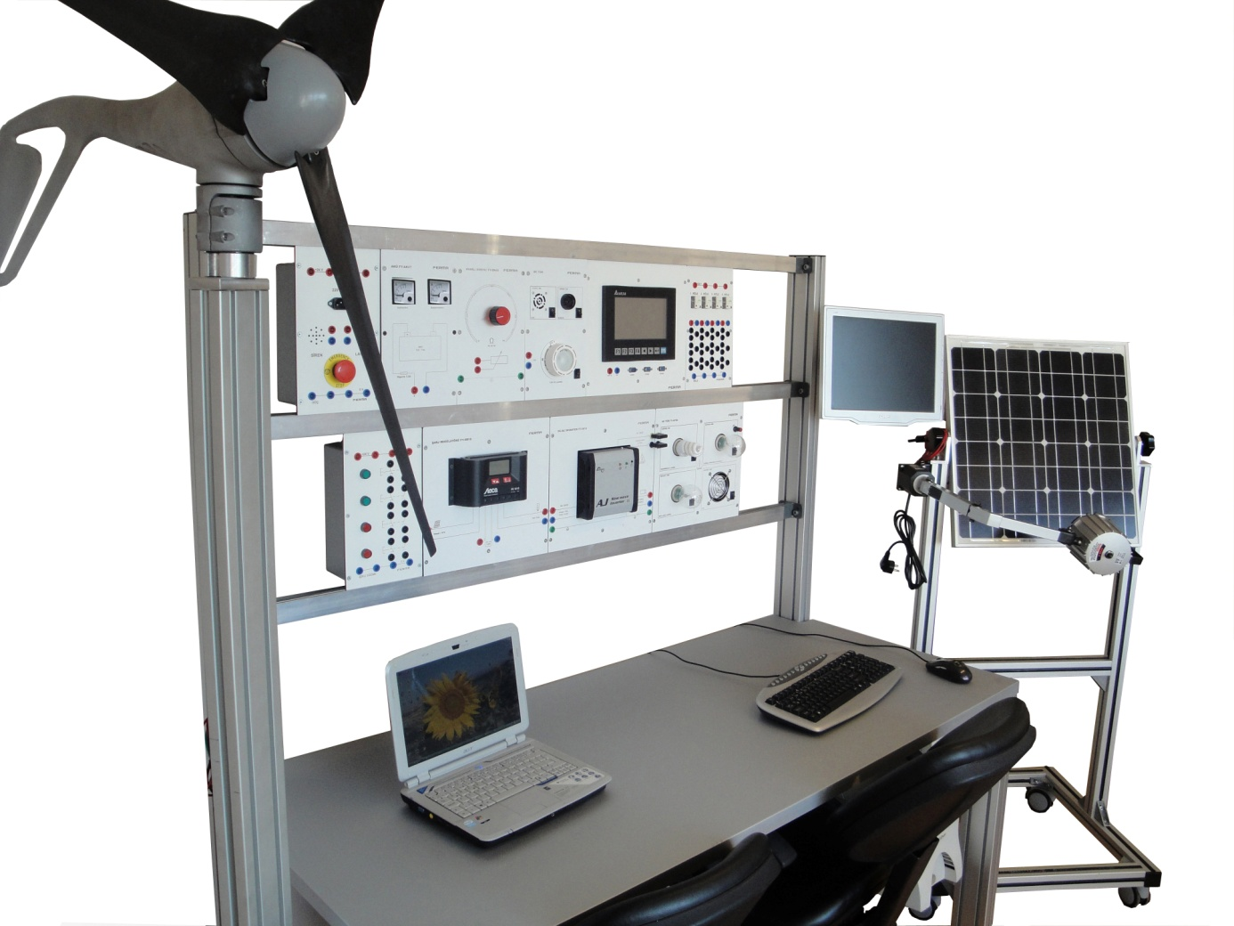

FY-SR10 Solar Charge Controller
- Charge / decharge current : 10 A
- Automatic detection of voltage
- Graphical LCD display for operating parameters, fault messages, self teste
- Load disconnection depending on SOC, automatic load reconnection
- Multistage charging technology
- PWM control
- Temperature compensation
- Integrated datalogger
- Night light and morning light function
- 4 mm banana sockets for solar panel, accumulator and DC load
- Dimensions : 297mm x 300mm x 65mm

FY-IN10 DC-AC inverter
- On/off switch
- 12 VDC input
- Output voltage: sinusoidal 230V AC ±10%
- Frequency: 50Hz ±%10 (crystal controlled)
- Power : 275 VA
- Efficiency : %93
- LED display of operating status
- Acoustic alarm to signal warnings
- Over temperature and overload protection
- Pole reversal protection
- Short circuit protection
- Cut out for excess battery voltage
- Extra solar panel input (integrated charge controller)
- 4 mm banana sockets for solar panel, accumulator, earth contact and AC output
- Dimensions : 297mm x 300mm x 65mm

FY-AK07 Accumulator
- Voltage : 12V
- Capacity : 7Ah
- Recahergable
- Over current protection
- 0-15VDC analog voltmeter, 0-10A analog ampermeter
- 4 mm banana sockets
- Dimensions : 297mm x 160mm x 85mm

FY-DR40 Variable resistor
- 0…1 kOhm/40W adjustable potantiometer
- Max. current 0,2A
- 4 mm banana sockets
- Dimensions : 297mm x 160mm x 50mm

FY-DY03 DC load
- Operating voltage: 12VDC
- Fan: 5W
- Buzzer : 5W
- Lamp: 10W
- Each unit activated individually
- 4 mm banana sockets
- Dimensions : 297mm x 160mm x 50mm

FY-AY04 AC load
- Operating voltage: 220VAC
- Energy saving lamp : 5W
- Lamp with adjustable brightness(dimmer): 25W
- Halogen lamp:18W
- Fan: 14W
- Each unit activated individually
- 4 mm banana sockets
- Dimensions : 297mm x 300mm x 65mm
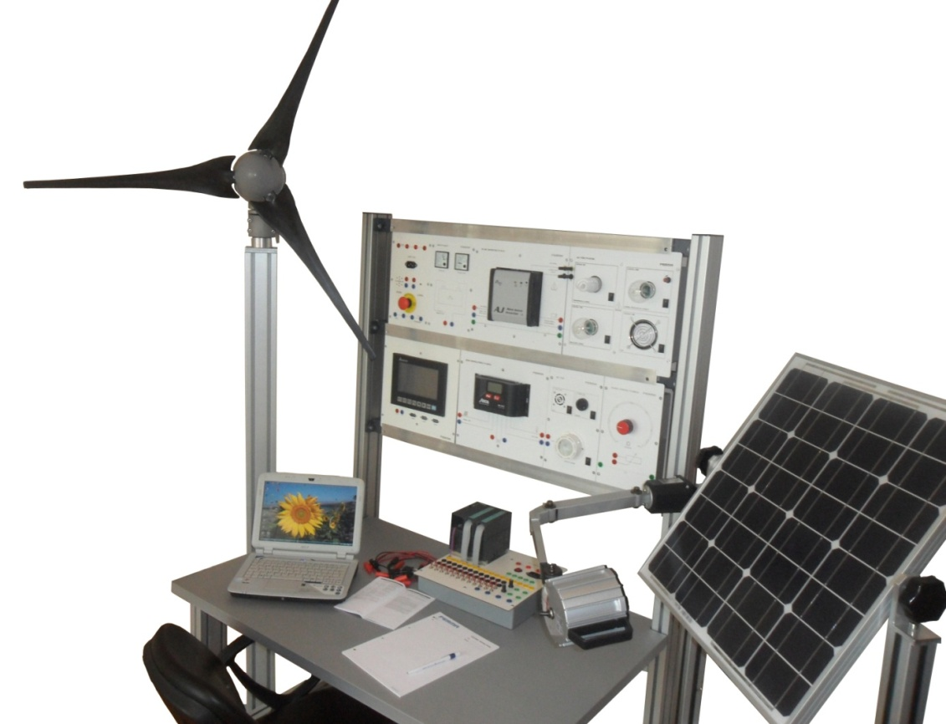

Available experiments, which can be applied with the sets are;
- Investigating the characteristics of solar panel (voltage, current, power)
- Learning about various types of connection configurations for solar modules
- Installation of PV systems
- Design and testing of a standalone PV systems in direct operation
- Design and testing of a standalone PV system in storage operation
- Design and testing of a standalone PV system for the generation of 230 V AC voltage
- Design and operation principles of small wind power plants
- Energy storage and optimisation of wind turbine system
- Design of an off-grid system for the generation of a 230V AC voltage
- Explore hybrid systems for off-grid power supply using wind power and photovoltaic systems
- The management and consumption of the generated power on AC and DC loads

